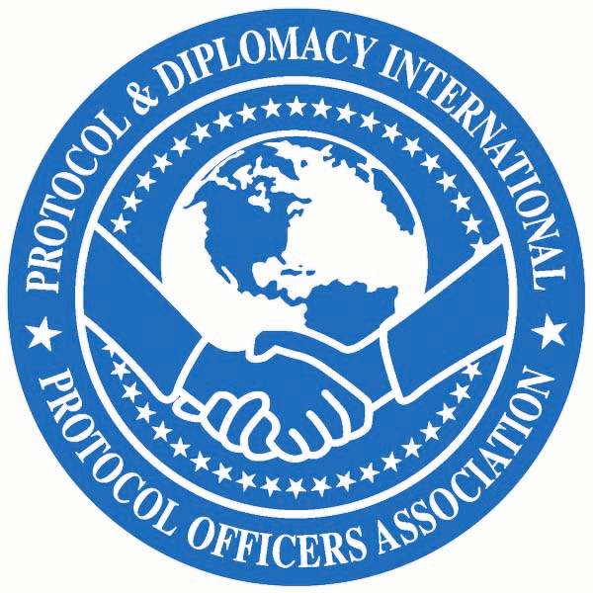

Sixth Educational Protocol Conference Agenda
August 15-18, 2007
Hilton Post Oak Hotel
2001 Post Oak Blvd.
Houston, TX 77056
(Schedule is subject to change)

Wednesday, August 15

9:30 - 11:00 a.m. Conference Committee meeting in the Westheimer Room (near the Ballroom on the first floor)

12:30 - 4:00 p.m. PDI Board Meeting in the Director’s Room

4:00 - 6:00 p.m. Registration in the Westheimer Room on the first floor (towards the ballroom)

5:00 - 7:00 p.m. Welcome Reception and Silent Auction Post Oak Room (behind the Vendome Room)

Attire: Business Casual

Come and meet your colleagues.

Note: All sessions will be held in Ballroom A on the first floor (classroom set up)

PDI Workroom/Office/Storage in the Westheimer Room (near the Ballroom on the first floor)

Attire: Business Casual unless otherwise noted. Please see attire note for Thursday.

Thursday, August 16

7:30 - 8:30 a.m. Continental Breakfast in Ballroom A

Conference Registration in foyer of Ballroom A

Attire: Thursday is a very full day with off-site activities including a reception with business attire after the mosque and temple visits. We have been advised that women visitors are not required to wear headscarves when the mosque is not in prayer sessions and there is no specific dress code except for what one would ordinarily wear at a place of worship. However, a headscarf would be a sign of respect and would allow the women to experience the mosque as it would be on other occasions. We recommend women dress modestly and have a scarf as a courtesy.

Shoes will need to be removed before entering the mosque and temple. We also recommend wearing comfortable shoes as there will be some walking among the various buildings. We will depart directly from the temple visit to the reception with the Consular Corps of Houston. Since there will be no time to change men may wish to bring a jacket and tie to put on for the reception.

8:20 - 8:45 a.m. Welcoming Remarks and Introductions
Sonia Garza-Monarchi, President, Protocol & Diplomacy International

8:45 - 9:15 a.m. Diversity and Community Events
Presented by: Susan Christian, Deputy Director for Special Events, Mayor’s
Office of Special Events, City of Houston

9:15 - 10:15 a.m. Protocol and Problem Solving – At Home and Abroad
Presented by: Ambassador James R. Jones, former U.S. Ambassador to Mexico
10:15 - 10:30 a.m. Break

10:30 - 11:30 a.m. Dignitary Visits from the Visitor’s Perspective
Moderated by: Brian Langley, Assistant Chief of Protocol for Visits, U.S. Department of State
Presented by: Tom Corcoran, Manager, Travel & Visits Liaison, Australian Embassy and Richard Rodgers, Senior Visits Officer, British Embassy

11:45 - 1:15 p.m. Luncheon Presentation: Presidential Inaugurations

Presented by: Tom Groppel, (former) Ceremonies and Special Events Director, U.S. Army Military District of Washington

1:30 p.m. Board bus on side of Hilton Hotel

1:45 p.m. Depart for tour of places of worship

2:30 - 5:30 p.m. Places of Worship
To gain a better understanding of some of the world’s religions and the impact religion has on their respective societies we will tour local places of worship and learn the appropriate protocol for visiting. We have asked our hosts to share their religious traditions with us as they are actually practiced. Shoes should be removed before entering the mosque and temple. Men and women may be seated separately at the temple and we will sit on the floor at the mosque.
There will be a few chairs available for anyone who cannot sit on the floor. Our hosts will advise us on other proper protocol.

2:30 p.m. Arrive at the South Zone Mosque for visit and presentation

3:30 p.m. Depart to Mandir

3:45 p.m. Arrive at Mandir for visit and presentation

5:30 p.m. Depart to City Hall.

6:30 - 8:30 p.m. City Hall Reception with Consular Corps of Houston
Hosted by: Houston International Protocol Alliance

Attire: Business

8:30 p.m. Buses depart City Hall for hotel.

Friday, August 17

8:00 - 9:00 a.m. Continental Breakfast in Ballroom A

8:00 - 8:30 a.m. Board Meeting

8:00 - 10:45 a.m. Gift vendors available with display tables

9:00 - 10:00 a.m. Precedence and Forms of address
Presented by: April Guice, Protocol Officer, Ceremonials Division, U.S.
Department of State

10:00 - 10:15 a.m. Break

10:15 - 11:15 a.m. Protocol – Precept and Practice
Presented by: H.E. S.M. Gavai, Consul General of India for AL, AR, FL, GA, KS,
LA, MS, OK, TX

11:15 - 12:15 p.m. Protocol and the U.S. Secret Service
Presented by: Timothy Foley, Special Agent in Charge, U.S. Secret Service

12:30 - 2: 00 p.m. Luncheon Presentation: U.S. China Relations and the Interaction of Business & Government Delegations with Host Institutions in the U.S.
Presented by: Steven W. Lewis, Ph.D., fellow in Asian Studies at the James A. Baker III Institute for Public Policy

2:15 - 2:45 p.m. Military Protocol vs. Civilian Protocol
Presented by: Rafael D.L. Quezada, Col, USAF “Q”, Chief, International Affairs and Foreign Policy Advisor to Commander, Pacific Air Forces and Brian Adams, Civ, DAF Chief of Protocol, 35th Fighter Wing

2:45 - 3:45 p.m. Security and International Travel
Presented by: Tom Winn, Consulting and Special Projects Manager, ASI Group

3:45 - 4:00 p.m. Break

4:00 - 4:45 p.m. Airport International Arrivals “From Worst to First”
Presented by Saba Abashawl, Interim Deputy Director, Marketing, Communications and Community Affairs, Houston Airport System and Mr. Bob Keller, Assistant Director of Field Operations, Houston Field Office, Customs and Border Protection

Free Evening Many of our members requested a free evening to allow time to meet and
interact informally with colleagues. See website for restaurants and places of interest.

Saturday, August 18

8:00 - 9:00 a.m. Hot Buffet Breakfast and Presentation by 2008 Host City in Ballroom A

9:00 - 9:45 a.m. One Thousand and One Nights in Qatar: Ethics of Everyday Living
Presented by: Diana Untermeyer, wife of the U.S. Ambassador to the State of Qatar

9:45 - 10:45 a.m. Celebrating Close and Enduring Associations: The State Visit of Her Majesty Queen Elizabeth II to the United States
Presented by: Richard Rodgers MVO, Senior Visits Officer, British Embassy Washington

10:45 - 11:00 a.m. Break

11:00 - 12:00 p.m. Presentation Skills
Presented by: Deborah Rinner, Director of International Protocol &
Corporate Etiquette Programs, Tero International, Inc.

12:00 - 12:30 p.m. PDI Updates: Closing remarks, Presentations and Evaluation Forms

12:30 p.m. Conference Concludes

1:00 - 2:30 p.m. PDI Board meeting in Directors Room

